Spring Boot DataJPA Many to Many
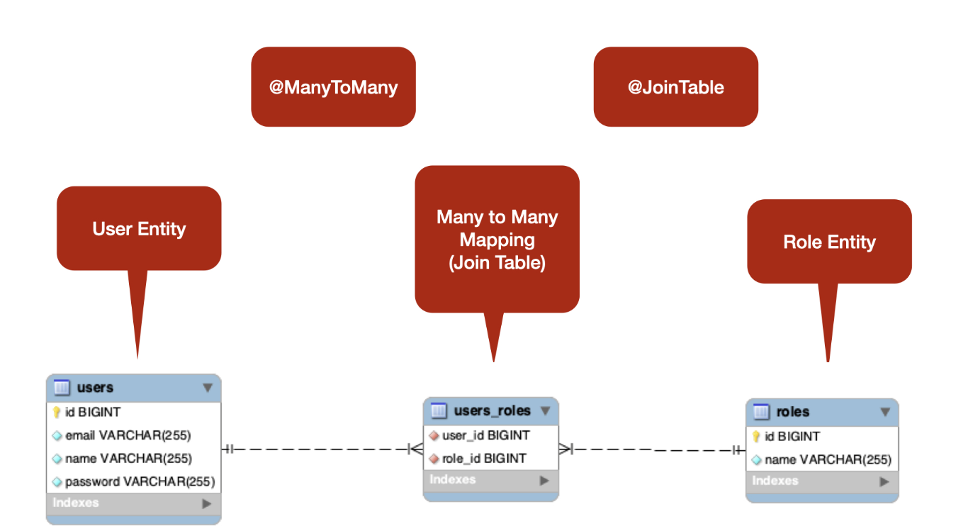
pom.xml

<dependency>
<groupId>org.springframework.boot</groupId>
<artifactId>spring-boot-starter-data-jpa</artifactId>
</dependency>
<dependency>
<groupId>org.springframework.boot</groupId>
<artifactId>spring-boot-starter-web</artifactId>
</dependency>

<dependency>
<groupId>com.mysql</groupId>
<artifactId>mysql-connector-j</artifactId>
<scope>runtime</scope>
</dependency>
<dependency>
<groupId>org.projectlombok</groupId>
<artifactId>lombok</artifactId>
<optional>true</optional>
</dependency>
<dependency>
<groupId>org.springframework.boot</groupId>
<artifactId>spring-boot-starter-test</artifactId>
<scope>test</scope>
</dependency>

application.propertoes

spring.datasource.url = jdbc:mysql://localhost:3306/mydb
spring.datasource.username = root
spring.datasource.password = 1234

# Hibernate ddl auto (create, create-drop, validate, update)
spring.jpa.hibernate.ddl-auto = create-drop

logging.level.org.springframework.security=DEBUG

spring.jpa.show-sql=true
spring.jpa.properties.hibernate.format_sql=true

#spring.jpa.hibernate.naming.implicit-strategy=org.hibernate.boot.model.naming.ImplicitNamingStrategyLegacyJpaImpl
#spring.jpa.hibernate.naming.physical-strategy=org.hibernate.boot.model.naming.PhysicalNamingStrategyStandardImpl

模型層 - 建 JPA 實體
在此步驟中，我們將建立使用者和角色 JPA 實體，並在它們之間建立多對多關係。讓我們使用 JPA 註釋在Users和Roles實體之間建立多對多關係

import javax.persistence.*;
import lombok.AllArgsConstructor;
import lombok.Data;
import lombok.NoArgsConstructor;
@Data
@NoArgsConstructor
@AllArgsConstructor
@Entity
@Table(name = "roles")
public class Role {

@Id
@GeneratedValue(strategy = GenerationType.IDENTITY)
private Long id;
private String name;
}

import javax.persistence.*;
import lombok.AllArgsConstructor;
import lombok.Data;
import lombok.NoArgsConstructor;
import java.util.Set;

@Data
@NoArgsConstructor
@AllArgsConstructor
@Entity
@Table(name = "users")
public class User {
@Id
@GeneratedValue(strategy = GenerationType.IDENTITY)
private Long id;
private String name;

@Column(nullable = false, unique = true)
private String username;

@Column(nullable = false, unique = true)
private String email;

@Column(nullable = false)
private String password;

@ManyToMany(fetch = FetchType.EAGER, cascade = CascadeType.ALL)
@JoinTable(name = "users_roles",
joinColumns = @JoinColumn(name = "user_id", referencedColumnName = "id"),
inverseJoinColumns = @JoinColumn(name = "role_id", referencedColumnName = "id")
)
private Set<Role> roles;
}

存儲庫
import org.springframework.data.jpa.repository.JpaRepository;
import java.util.Optional;
public interface UserRepository extends JpaRepository<User, Long> {
Optional<User> findByUsername(String username);
Boolean existsByEmail(String email);
Optional<User> findByUsernameOrEmail(String username, String email);
boolean existsByUsername(String username);
}

import org.springframework.data.jpa.repository.JpaRepository;
import java.util.Optional;
public interface RoleRepository extends JpaRepository<Role, Long> {
Optional<Role> findByName(String name);
}

到MySQL Workbench新增資料

INSERT INTO `users` VALUES
(1,'mary@gmail.com','mary','m123','mary'),
(2,'admin@gmail.com','admin','a123','admin');

INSERT INTO `roles` VALUES (1,'ROLE_ADMIN'),(2,'ROLE_USER');

INSERT INTO `users_roles` VALUES (2,1),(1,2);

新增UserController

import java.util.List;

import org.springframework.beans.factory.annotation.Autowired;
import org.springframework.web.bind.annotation.GetMapping;
import org.springframework.web.bind.annotation.RestController;

import com.example.demo.model.*;

@RestController
public class UserController {
@Autowired
UserRepository userRepos;

@GetMapping(value="/users")
public List<User> getAllUsers(){
return userRepos.findAll();
}

}
http://localhost:8080/users
[
{
"id": 1,
"name": "mary",
"username": "mary",
"email": "mary@gmail.com",
"password": "m123",
"roles": [
{
"id": 2,
"name": "ROLE_USER"
}
]
},
{
"id": 2,
"name": "admin",
"username": "admin",
"email": "admin@gmail.com",
"password": "a123",
"roles": [
{
"id": 1,
"name": "ROLE_ADMIN"
}
]
}
]

